Main page

Contents

Introduction page

Performance of the system

Er diagram

Class diagram

Implementation

In our project, there are two main concepts…-service provider & service requester…

Main interface  
 The system divided into four parts  
 Admin

Lecturer

Tech Officer

Student

Thank you

Project Main Interface

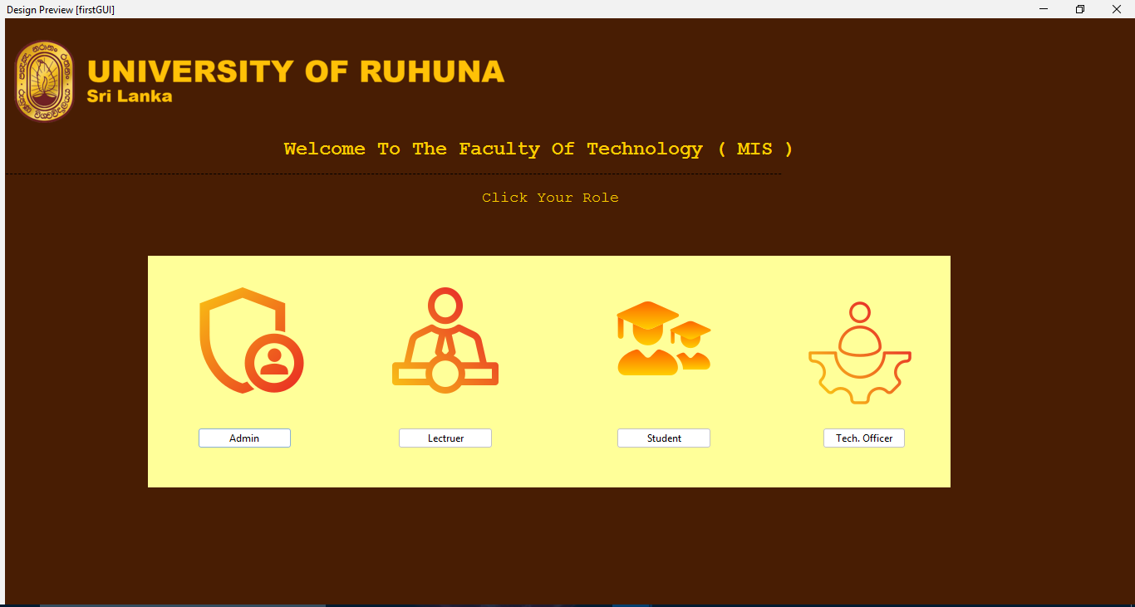

Admin Main Interface

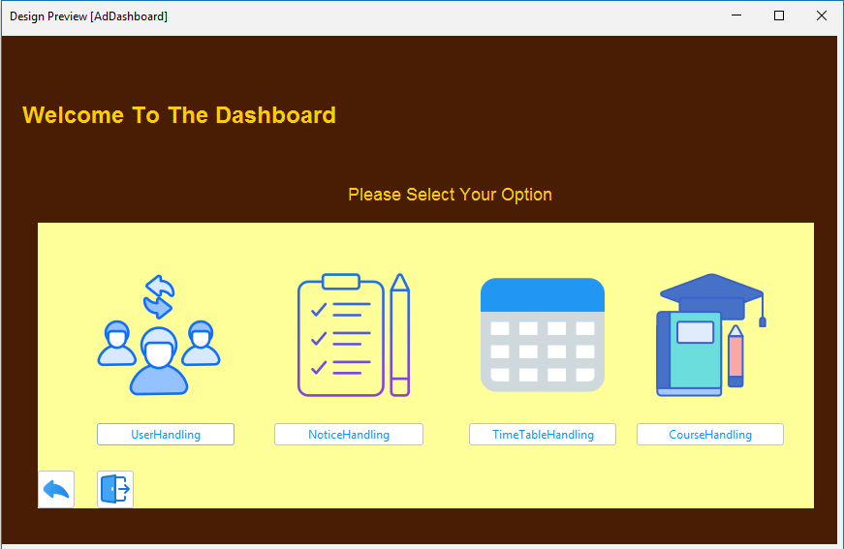

Lectuter (Main Interface)

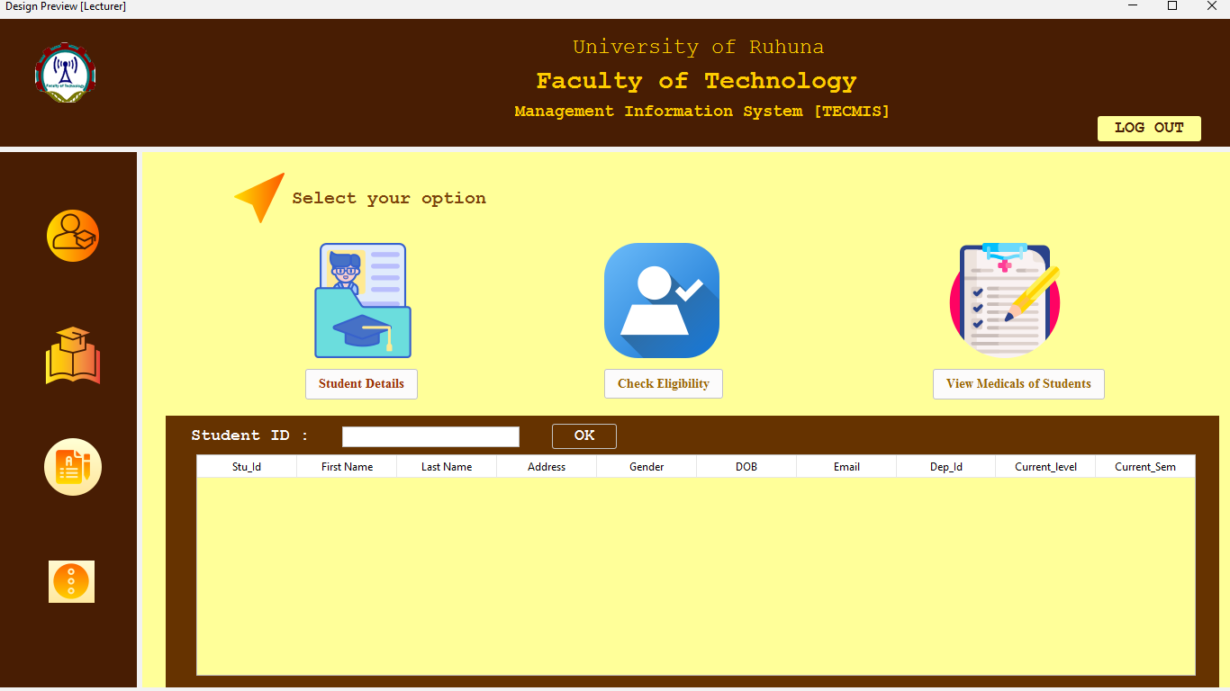

Tech Officers (Main Interface)

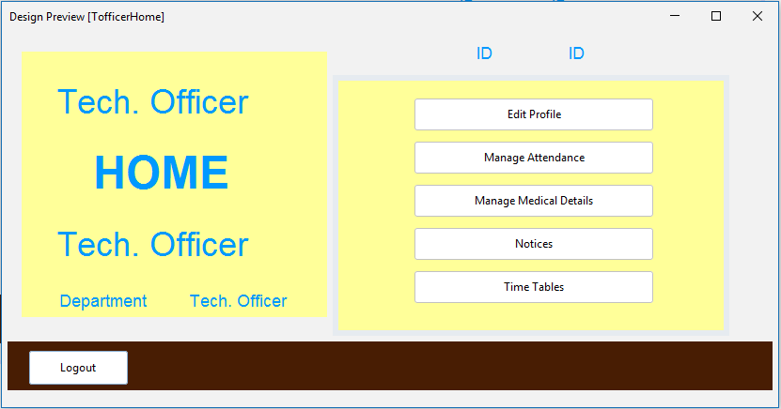

Student Screen shot( Main Interface)

